FINALS-LAB 1-INFOE 3
Stephen Gabarda

def mask_sensitive_data(input_str, mask_char='X'):

parts = input_str.split('-')

masked_parts = []
for part in parts:
if len(part) <= 4:

masked_parts.append(mask_char * len(part))
else:

unmasked_part = part[-4:]
masked_part = mask_char * (len(part) - 4) + unmasked_part
masked_parts.append(masked_part)

return '-'.join(masked_parts)

credit_card = "4532-8812-9001-4321"
masked_card = mask_sensitive_data(credit_card)
print(f"Original: {credit_card}")
print(f"Masked: {masked_card}")

phone_number = "123-456-7890"
masked_phone = mask_sensitive_data(phone_number)
print(f"\nOriginal: {phone_number}")
print(f"Masked: {masked_phone}")

print(f"\nMasked with *: {mask_sensitive_data(credit_card, '*')}")
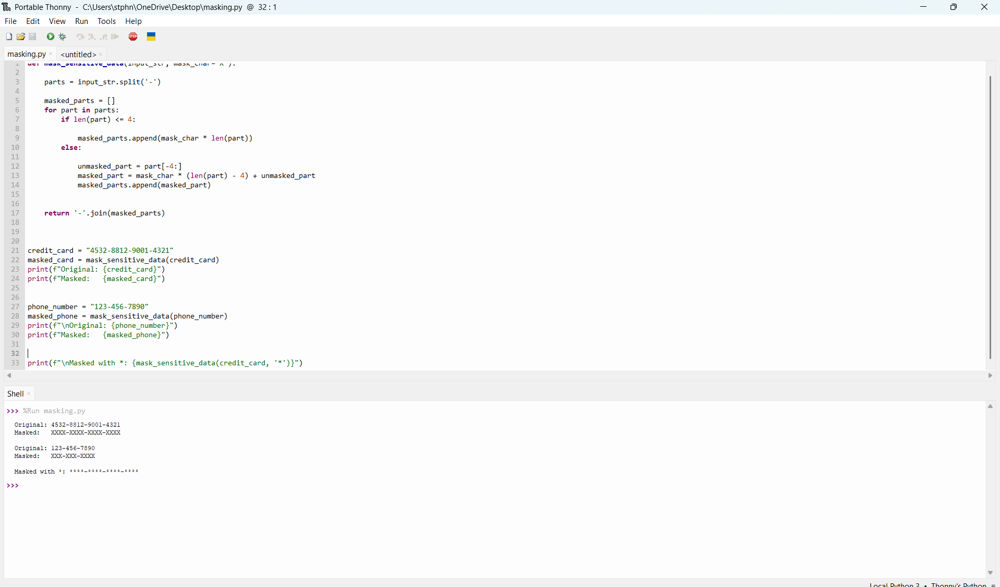

Objective
- Implement a "Last-Four" masking rule to protect PII while preserving the last 4 characters of each segment for customer verification.

